Encephalopathy and toxic encephalopathy
Prior to FY 2021, an Excludes1 note under code subcategory G93.4- (other and unspecified encephalopathy) prevented the assignment of a code from subcategory G93.4- when a patient also had a diagnosis of toxic encephalopathy (reported with ICD-10-CM code G92).
This Excludes1 note has been changed to an Excludes2 note for FY 2021. This means coders can now report both toxic encephalopathy and metabolic encephalopathy.
On initial consideration this may seem like a benign change since encephalopathy is most often a secondary diagnosis and coding two MCCs has the same effect on the MS-DRG as only reporting one MCC. However, there are occasions when the ability to code both may lead to a higher MS-DRG.
Consider this example of a scenario I have seen several times:
A patient presents with altered mental status. She is noted to have a urinary tract infection (UTI) and has some improvement in mental status with treatment of the UTI. The providers also noted that two of her long-term medications, one more recently prescribed, can cause altered mental status. Some medication adjustments are made followed by further improvement in mental status. The admission is five days long and the final diagnosis is encephalopathy due to polypharmacy with a metabolic component due to UTI.
If toxic encephalopathy (encephalopathy due to drug) is sequenced as the principal diagnosis, metabolic encephalopathy as a secondary diagnosis will act as an MCC. The table below shows the coding and MS-DRG difference between FY 2020 and FY 2021.
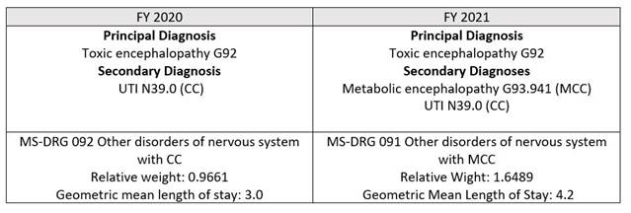

The change from an Excludes1 to an Excludes2 note for FY 2021 makes it possible to code the metabolic encephalopathy, allowing hospitals to capture the full clinical picture, appropriate reimbursement to cover the cost of care for the patient, and an expected length of stay that more closely matches the actual length of stay.

